Ans1: because the value of integer is so large to store it in integer (int), that’s why it’s need long integer to be used.as a format specifier %d should be replace by %ld.

Ans2:

Swap numbers

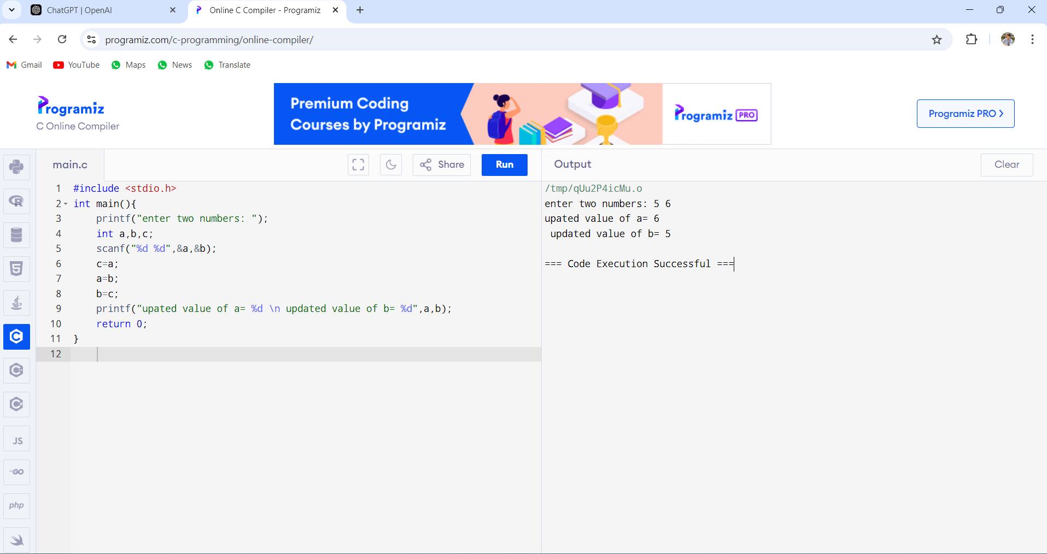

Ans3: salary after tax deduction

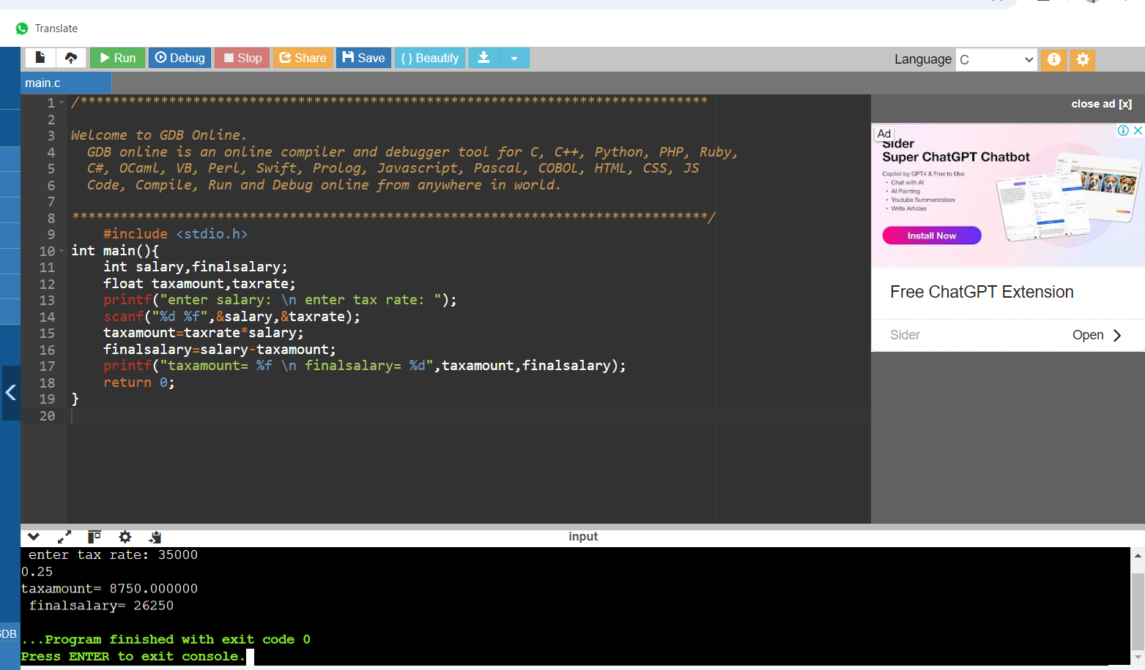

Ans4: total cost of fuel on trip

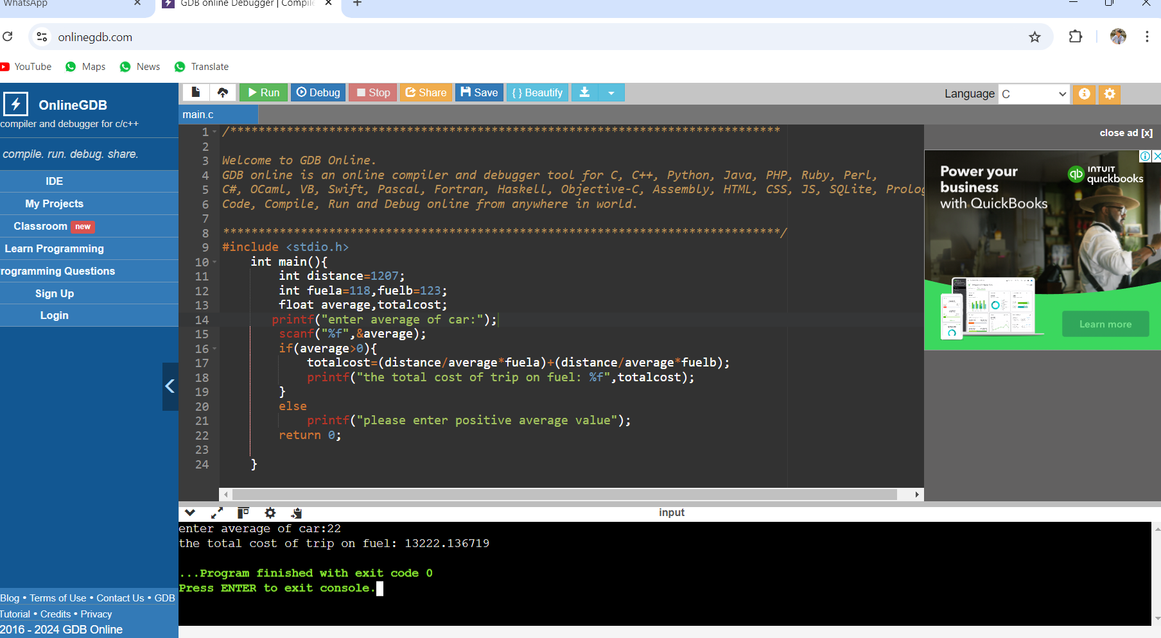

Ans5: interest rate on principle amount

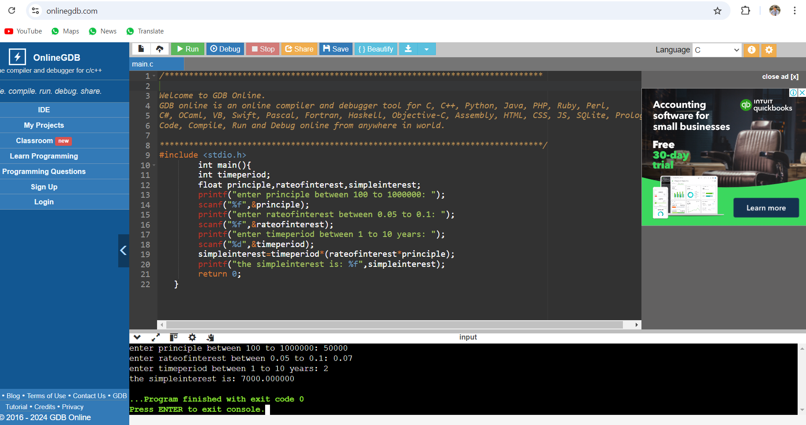

Ans6: slope of two points

